**Flame Sensor**

**Introduction**

This course will use the Raspberry Pi to capture the signal from the flame sensor and controls the LED light on and off based on the captured signal.

**Experimental Materials**

Raspberry Pi *1

Breadboard *1

Flame Sensor *1

ADC0832 *1

Led *1

Dupont Line

**The Preparatory Work**

1. Install python interpreter in your Raspberry Pi system

2. Install the RPi.GPIO library in your Raspberry Pi system

3. Install the wiring Pi library in your Raspberry Pi system

For more details, please refer to the attachment for installing the python interpreter and corresponding libraries in the Raspberry Pi system.

Product Description

Brief Introduction

The flame sensor (infrared receiver transistor) is a sensor specially used by robots to search for fire sources. The flame sensor uses the characteristics that infrared rays are very sensitive to the flame, using a special infrared receiver tube to detect the flame and converts the brightness of the flame into a voltage signal, which is input to the central processor, and the CPU makes corresponding program processing according to the change of the signal.

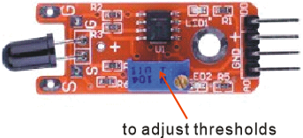

**Characteristic Parameters**

◆ The flame sensor is most sensitive to the flame and also responds to ordinary light. It is generally used for flame alarm purposes.

◆ The sensor and the flame must be kept at a distance so as not to damage the sensor at high temperatures

◆The larger the flame, the farther the test distance.

◆The working voltage is 3.3v -5V

Wiring diagram

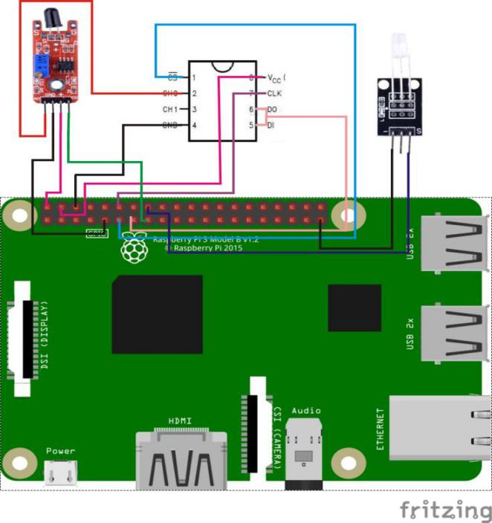

**The sample code**

1. **Python Code**

#!/usr/bin/env python

import RPi.GPIO as GPIO

import ADC0832

import time

Flame_DO_Pin = 15

LedPin = 16

thresholdVal = 150

def init():

GPIO.setmode(GPIO.BOARD)

GPIO.setup(Flame_DO_Pin, GPIO.IN, pull_up_down=GPIO.PUD_UP)

GPIO.setup(LedPin, GPIO.OUT)

ADC0832.setup()

def loop():

while True:

global digitalVal, analogVal

digitalVal = GPIO.input(Flame_DO_Pin)

if(digitalVal == 1):

print 'DO is %d' % digitalVal

analogVal = ADC0832.getResult(0)

print 'Current analog value is %d'% analogVal

if(analogVal < thresholdVal):

GPIO.output(LedPin, GPIO.HIGH)

time.sleep(0.2)

else:

GPIO.output(LedPin, GPIO.LOW)

if __name__ == '__main__':

init()

try:

loop()

except KeyboardInterrupt:

ADC0832.destroy()

print 'The end !'

1. **C Code**

#include <wiringPi.h>

#include <stdio.h>

#include <string.h>

#include <errno.h>

#include <stdlib.h>

#define ADC_CS 0

#define ADC_CLK 1

#define ADC_DIO 2

#define Flame_DO_Pin 3

#define LedPin 4

#define thresholdVal 150

typedef unsigned char uchar;

typedef unsigned int uint;

uchar get_ADC_Result(void)

{

uchar i;

uchar dat1=0, dat2=0;

digitalWrite(ADC_CS, 0);

digitalWrite(ADC_CLK,0);

digitalWrite(ADC_DIO,1); delayMicroseconds(2);

digitalWrite(ADC_CLK,1); delayMicroseconds(2);

digitalWrite(ADC_CLK,0);

digitalWrite(ADC_DIO,1); delayMicroseconds(2);

digitalWrite(ADC_CLK,1); delayMicroseconds(2);

digitalWrite(ADC_CLK,0);

digitalWrite(ADC_DIO,0); delayMicroseconds(2);

digitalWrite(ADC_CLK,1);

digitalWrite(ADC_DIO,1); delayMicroseconds(2);

digitalWrite(ADC_CLK,0);

digitalWrite(ADC_DIO,1); delayMicroseconds(2);

for(i=0;i<8;i++)

{

digitalWrite(ADC_CLK,1); delayMicroseconds(2);

digitalWrite(ADC_CLK,0); delayMicroseconds(2);

pinMode(ADC_DIO, INPUT);

dat1=dat1<<1 | digitalRead(ADC_DIO);

}

for(i=0;i<8;i++)

{

dat2 = dat2 | ((uchar)(digitalRead(ADC_DIO))<<i);

digitalWrite(ADC_CLK,1); delayMicroseconds(2);

digitalWrite(ADC_CLK,0); delayMicroseconds(2);

}

digitalWrite(ADC_CS,1);

pinMode(ADC_DIO, OUTPUT);

return(dat1==dat2) ? dat1 : 0;

}

int main(void)

{

uchar digitalVal = 1;

uchar analogVal = 0;

if(wiringPiSetup() == -1)

{

printf("setup wiringPi failed !");

return -1;

}

pinMode(ADC_CS, OUTPUT);

pinMode(ADC_CLK, OUTPUT);

pinMode(Flame_DO_Pin, INPUT);

pullUpDnControl(Flame_DO_Pin, PUD_UP);

pinMode(LedPin, OUTPUT);

while(1)

{

if((digitalVal = digitalRead(Flame_DO_Pin)))

{

printf("Do is %d.\n", digitalVal);

analogVal = get_ADC_Result();

printf("Current analog value is %d.\n", analogVal);

if(analogVal < thresholdVal)

{

digitalWrite(LedPin, HIGH);

}

delay(200);

}

else

{

digitalWrite(LedPin, LOW);

}

}

return 0;

}

**Experimental Phenomena**

When the flame sensor detects the flame and the intensity of the flame reaches the set threshold, the current flame sensor will be printed out in the command line interface of the Raspberry Pi system after the conversion of the ADC，when this value meet the set condition, Led will be on.